| **Test Name** | | | Menu Can Open The All Salinity Levels Window | | | |
| --- | --- | --- | --- | --- | --- | --- |
| **Use Case Tested:** | | | View A Water Quality Metric Across All Sensors | | | |
| **Test Description:** | | | The “Data” menu option is clicked, followed by the “All Salinity Levels” option and the window with all salinity levels is displayed. | | | |
| **Pre-conditions** | | | Must Not Be On The All Salinity Levels Screen | | | |
| **Post-conditions** | | | The currently displayed window should be that of the All Salinity Levels window | | | |
| **Notes:** | | **Unsure how else to demonstrate a button click other than through screenshots.** | | | | |
| **Result (Pass/Fail/Warning/Incomplete)** | | **Pass** | | | | |
|  | **TEST STEP** | | | **EXPECTED TEST RESULTS** | P | F |
|  | Click On Data On Menu | | | Menu opens up | X |  |
|  | Click On All Salinity Levels | | | All Salinity Levels Window Is Displayed | X |  |
|  |  | | |  |  |  |

**Test Output Screenshots**

Start

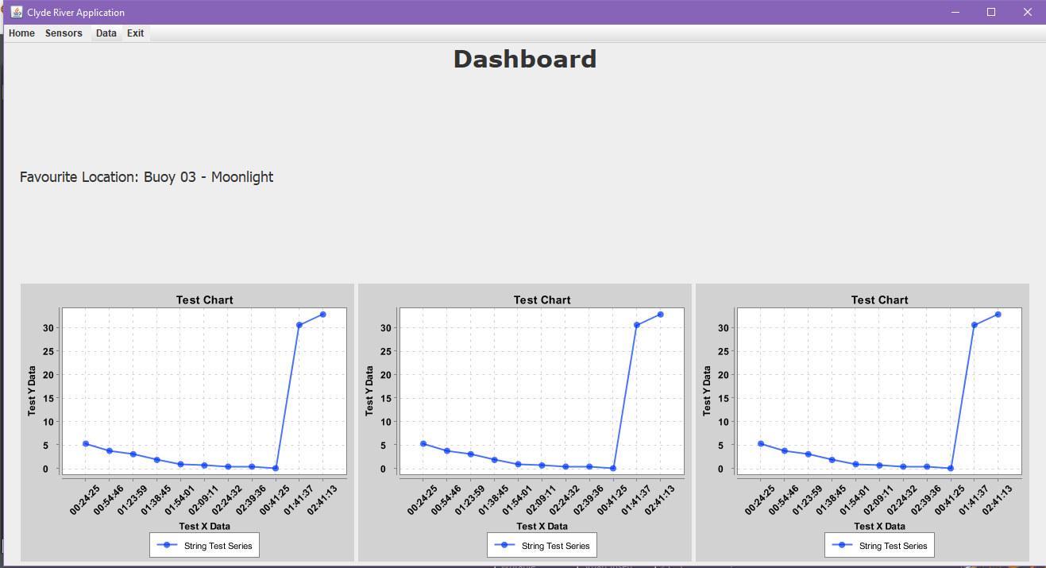

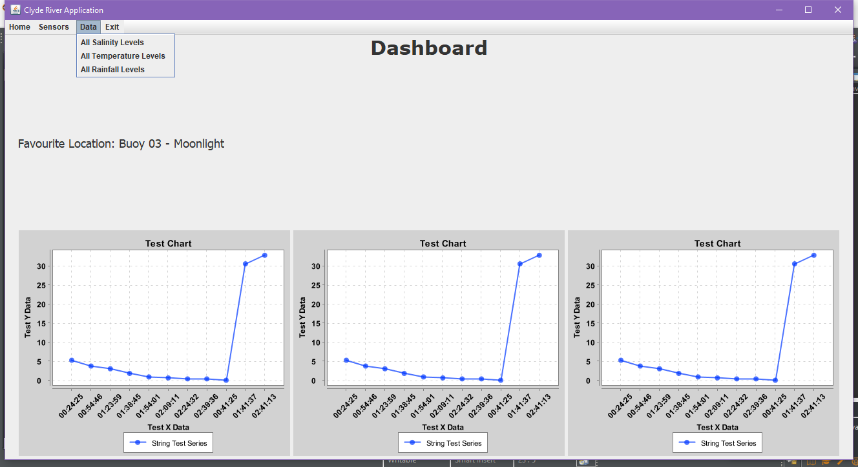

Result

